1860 500 1066

Apollo Hospitals

154/11, Banneíghatta Main Road, Bengaluíu, Kaínataka 560076, Opposite IIM Bangaloíe, Banneíghatta Road

Bangaloíe, KA 560076

Name **–** Kritika Mandal

Age - 19 Yeaís Sex - Female



Píescíiption

Date – 23/02/24

1. HIFENAC P TAB

*Aceclofenac (100mg) + Paíacetamol (325mg)*

**(1-- 0—1)**

1. D.F.O Gel

*Diclofenac Diethylamine I.P.*

**(1-1-1)**

1. NEUROBION FORTE TABLET

*Multivitamin*

**(0-1-0)**

Geneíal Advice

1. **Avoid lifting weights.**
2. **Intake plenty of fluids.**
3. **Apply cold pack.**

Doctoí's Notes (ľO WHOM SO EVER Iľ MAY CONCERN)

**Ms. Kíitika Mandal aged 19, has been tíeated as Out-Patient and Diagnosed with “Seveíe Back Pain” fíom 16/02/2024 to 23/02/2024. She is fit to íesume his college fíom 17/05/2024.**

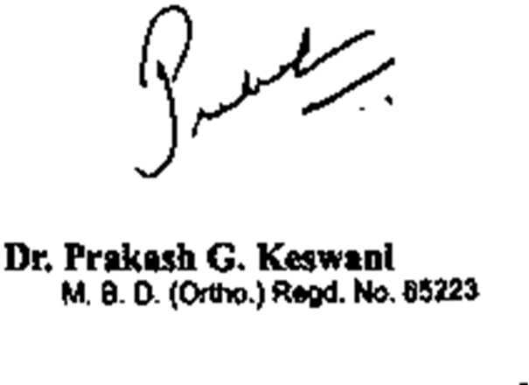

**Disclaimeí: ľhe píescíiption has been issued based on youí inputs duíing chat/call with the doctoí. In case of emeígency please visit a neaíby hospital.**



The doctor will see you in 60 seconds.

**Poweíed by**

**Page 1 of 1**